**Configuration – Dashboard**  
Bug Report

Cycle 2

Afrida Rahman

Last Executed: 02/06/2024

**Dashboard**

1. After a certain date, others field show null value. It shows data on charts but shows null value on fields.
2. Refresh button should refresh the page and clear the data.

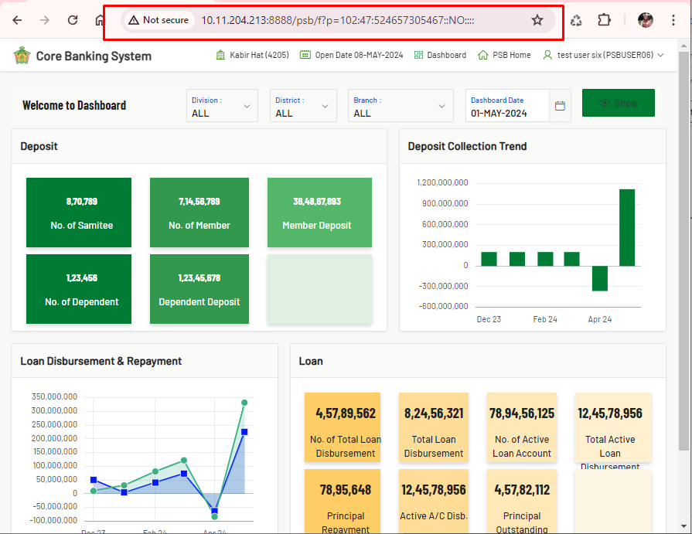

1. Information needed for “Loan Disbursement & Repayment”. In SRS information is given. And giving information above chart is more user friendly.

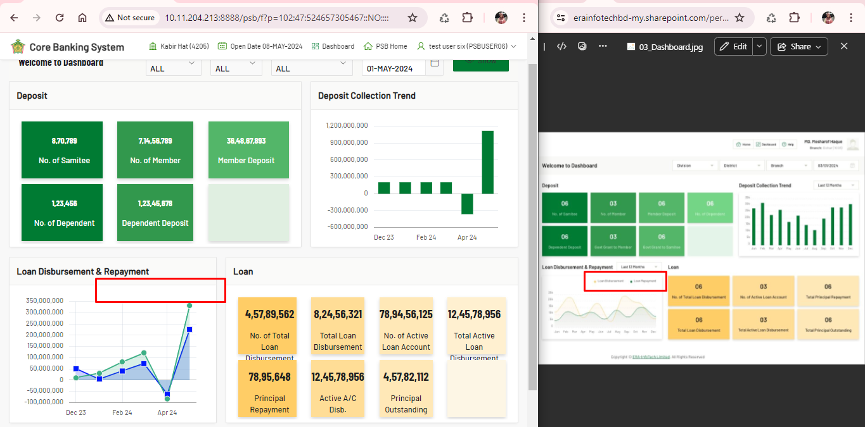

1. Dashboard “District-All” selection shows null data, as “Noakhali” is under Chittagong district it should shows all district value. **- Fixed**

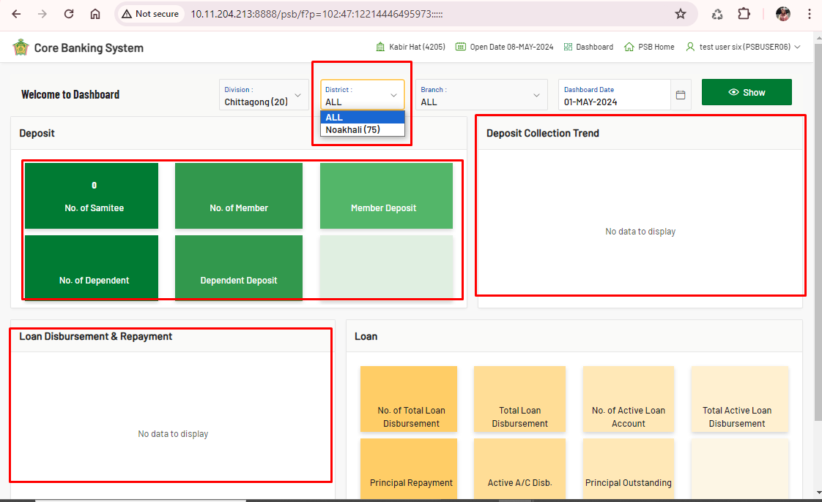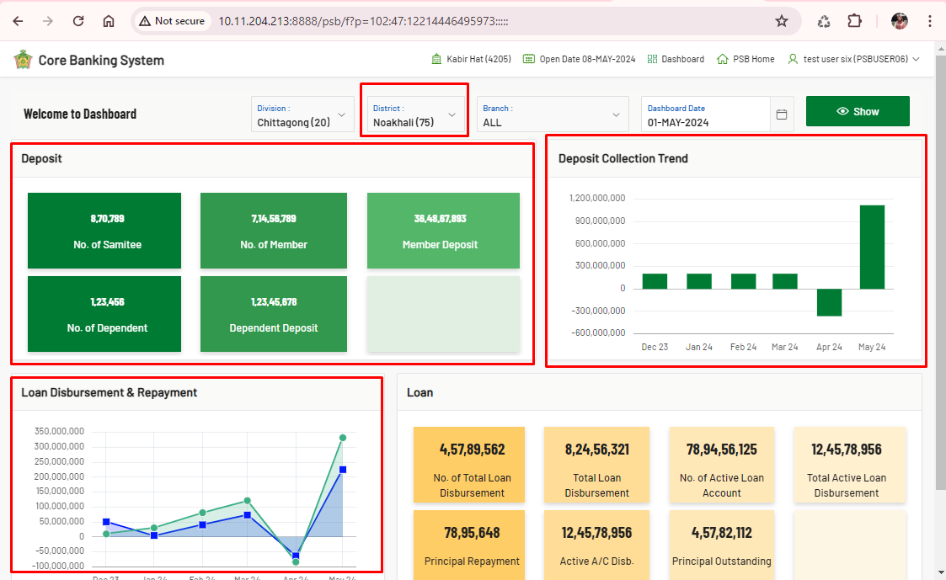

**Good to Have:**

1. A responsive webpage is more user-friendly.

